ACADEMIC PROJECT REPORT: GYM MANAGEMENT SYSTEM BACKEND ARCHITECTURE
1. Introduction
The Gym Management System is a backend application developed to simplify and automate the management of gym members, membership plans, and payment records. Traditionally, gym information is maintained manually, which can lead to errors, duplication of records, and difficulties in tracking memberships and payments. This project provides a digital solution that allows administrators to efficiently manage gym operations through a set of RESTful APIs.
The system enables the creation, retrieval, updating, and deletion of member records. In addition, it supports the creation of membership plans and the recording of payment transactions made by members. The application follows a client-server architecture where requests are sent through Postman, processed by the Spring Boot application, and stored in MongoDB.
The project demonstrates the practical implementation of backend development concepts including REST APIs, database integration, CRUD operations, dependency management, and API testing.

2. Technologies Used and Their Implementation in the Project
Spring Boot
Spring Boot served as the core framework for developing the backend of the Gym Management System. It provided the foundation for creating a structured, scalable, and maintainable application. The framework was responsible for handling all client requests, processing business logic, and coordinating communication between the application and the database. Through Spring Boot, RESTful web services were developed to support member management, membership plan management, and payment management functionalities.
The application was organized into multiple layers following a standard enterprise architecture. The controller layer received requests from clients through API endpoints, the service layer processed business operations, and the repository layer interacted with MongoDB to perform database operations. This layered architecture improved code organization and simplified maintenance. Spring Boot also managed application configuration, dependency injection, and server execution, enabling the development of a production-ready backend system with minimal configuration effort.
The framework played a central role in implementing all CRUD operations. Every action performed by the administrator, including creating a member, viewing member information, updating records, deleting members, creating membership plans, and recording payments, was processed through Spring Boot before being stored in the database.

MongoDB
MongoDB was implemented as the primary database management system for storing and managing all project data. As a NoSQL database, MongoDB stores information in document format, making it highly suitable for applications that require flexible and dynamic data structures.
In the Gym Management System, separate collections were maintained for members, membership plans, and payment records. Whenever a new member was registered, the member's information was stored in the members collection. Similarly, membership plans created by the administrator were stored in the plans collection, while payment transactions were stored in the payments collection.
MongoDB was integrated with Spring Boot through repository components, allowing the application to perform database operations efficiently. During Create operations, new documents were inserted into the database. During Read operations, existing documents were retrieved and returned to the user. During Update operations, existing documents were modified according to the latest information provided by the administrator. During Delete operations, unnecessary or inactive records were removed from the database.
The use of MongoDB ensured efficient storage, retrieval, and management of gym-related information while providing flexibility for future enhancements such as attendance tracking, trainer management, and membership renewal systems.

REST APIs
REST APIs formed the communication mechanism between the client application and the backend server. They enabled different functionalities of the Gym Management System to be accessed through standard HTTP requests. The APIs were designed according to REST architectural principles, ensuring a clear separation between the client and server components.
Different HTTP methods were implemented to perform specific operations. POST requests were used to create new members, membership plans, and payment records. GET requests were used to retrieve member information stored in the database. PUT requests allowed modification of existing member records, while DELETE requests enabled removal of member information from the system.
Each API endpoint represented a specific resource within the application and returned structured JSON responses containing relevant information. The APIs also returned appropriate HTTP status codes indicating the success or failure of an operation. This ensured proper communication between the client and the backend while providing clear feedback regarding request execution.
The implementation of REST APIs transformed the Gym Management System into a service-oriented application that can easily be integrated with web applications, mobile applications, or other external systems in the future.

Postman
Postman was used as the primary API testing and validation tool throughout the development process. Since the Gym Management System is a backend application, Postman acted as the client interface through which all APIs were tested and verified.
Every endpoint developed in the project was executed using Postman to ensure that it behaved according to the expected functionality. Requests containing member details, plan information, and payment data were sent to the server, and the responses generated by Spring Boot were carefully examined.
Postman provided detailed information regarding response data, execution time, response size, and HTTP status codes. These features were particularly useful for debugging and validating application behavior. The screenshots included in the project report were captured from Postman and demonstrate the successful execution of various operations such as member creation, member retrieval, member updating, member deletion, membership plan creation, and payment recording.
By using Postman, the reliability and correctness of the implemented APIs were verified before project completion.

Gradle Wrapper (Gradlew)
Gradle Wrapper, commonly referred to as Gradlew, was used as the project's build automation and dependency management tool. It simplified the process of managing external libraries required by the application and ensured that all project dependencies were downloaded and configured automatically.
The Gradle Wrapper eliminated the need for developers to install Gradle separately on their systems. Instead, the project contained all necessary configuration files required to execute Gradle commands directly. During development, Gradlew was used to build the application, resolve project dependencies, compile source code, execute tasks, and run the Spring Boot application.
Whenever modifications were made to the codebase, Gradlew ensured that the latest version of the project was compiled correctly. It also maintained consistency across different development environments, ensuring that the project behaved identically regardless of the machine on which it was executed.
The use of Gradlew significantly streamlined project development and contributed to efficient project management and deployment.

Command Prompt (CMD)
Command Prompt served as the primary execution environment for running and managing the Gym Management System during development. It provided direct access to project files, Gradle commands, and application execution processes.
The Command Prompt was used to navigate through project directories, execute build commands, launch the Spring Boot application, and monitor execution logs generated by the server. Through the command-line interface, developers were able to verify successful application startup, identify runtime errors, and ensure that all backend services were functioning correctly.
Command Prompt also played an important role in executing Gradle Wrapper commands that handled project compilation and dependency management. Additionally, it was used for interacting with MongoDB-related utilities whenever database verification was required.
By providing a direct interface to the development environment, Command Prompt enabled effective project execution, troubleshooting, and monitoring throughout the implementation process.

4. Payment Management Module
In addition to the standard CRUD operations, a Payment Management Module was implemented to handle membership fee transactions within the Gym Management System. This module was developed to maintain payment records and provide a mechanism for tracking financial transactions associated with gym memberships.
The payment functionality enhances the overall capability of the system by allowing administrators to record and manage member payments digitally rather than relying on manual record keeping. By integrating payment management into the application, the system becomes a more complete solution for gym administration.
Implementation of the Payment Module
The Payment Management Module was implemented using Spring Boot REST APIs and MongoDB. A dedicated payment entity was created to represent payment information within the application. Whenever payment details were submitted through the API, Spring Boot processed the request and created a corresponding payment record.
The payment record was then stored in MongoDB, ensuring that transaction information remained available for future reference. Each payment entry contains important information such as the payment amount, payment date, and associated member details. This implementation demonstrates the integration of business-specific functionality into the backend system and extends the application beyond basic member management operations.
Outcome of the Payment Module
The successful implementation of the payment module enabled the system to record and store payment transactions accurately. Testing through Postman confirmed that payment records were successfully created and stored in MongoDB. The module demonstrates how financial information can be managed efficiently within a backend application and contributes significantly to the overall functionality of the Gym Management System.

5. Screenshot-wise Output Explanation
Screenshot: POST_create_member

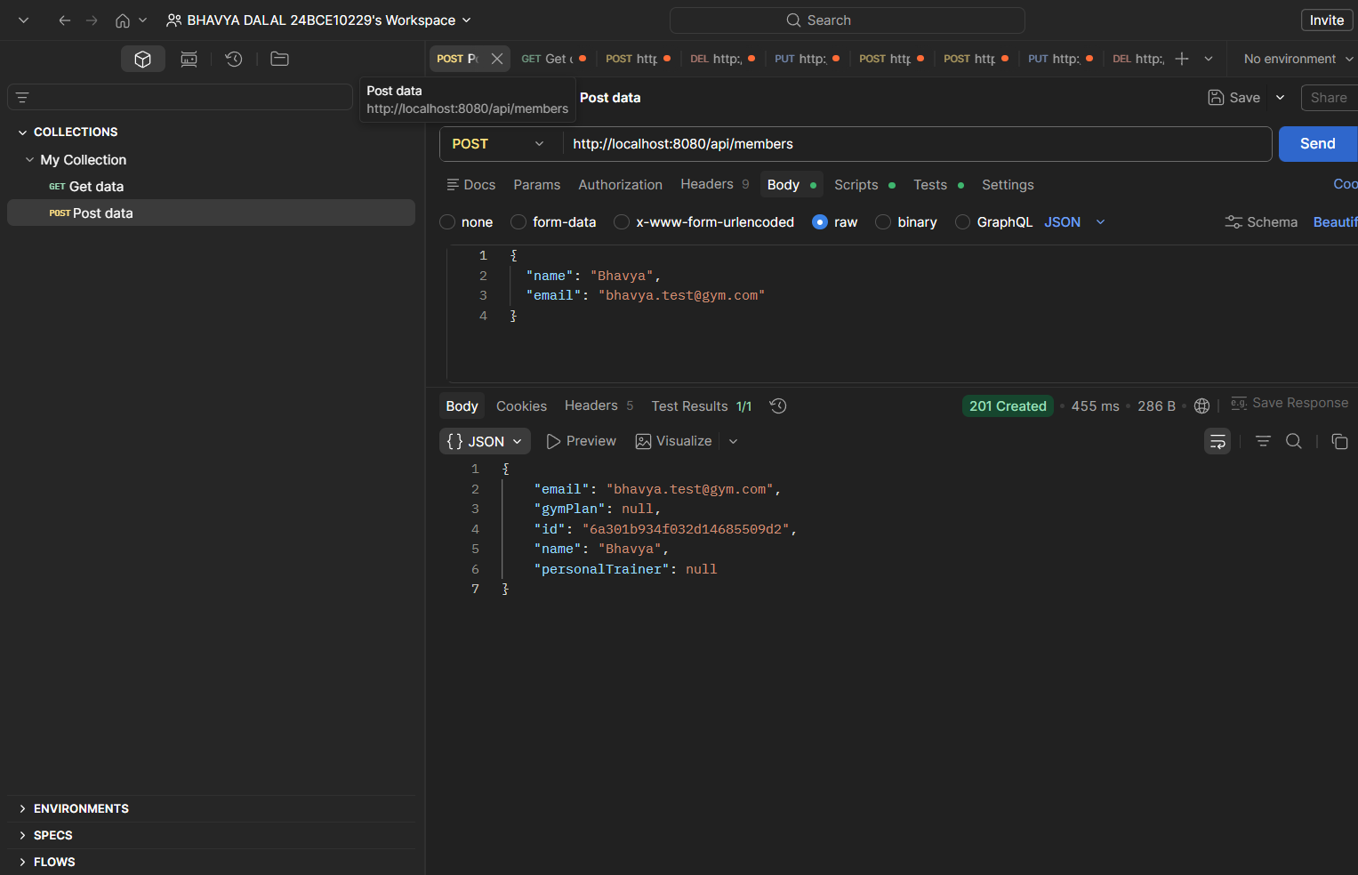
This screenshot demonstrates the successful creation of a new gym member using the member registration endpoint.
The request contains member information including the name and email address. After processing the request, the application stores the member details in MongoDB and automatically generates a unique identifier for the record.
The response displays the newly created member information along with the generated ID. The status code "201 Created" confirms that the member was successfully added to the database and the operation was completed without any errors.
This operation represents the "Create" functionality of the CRUD implementation.

Screenshot: GET_retrieve_members
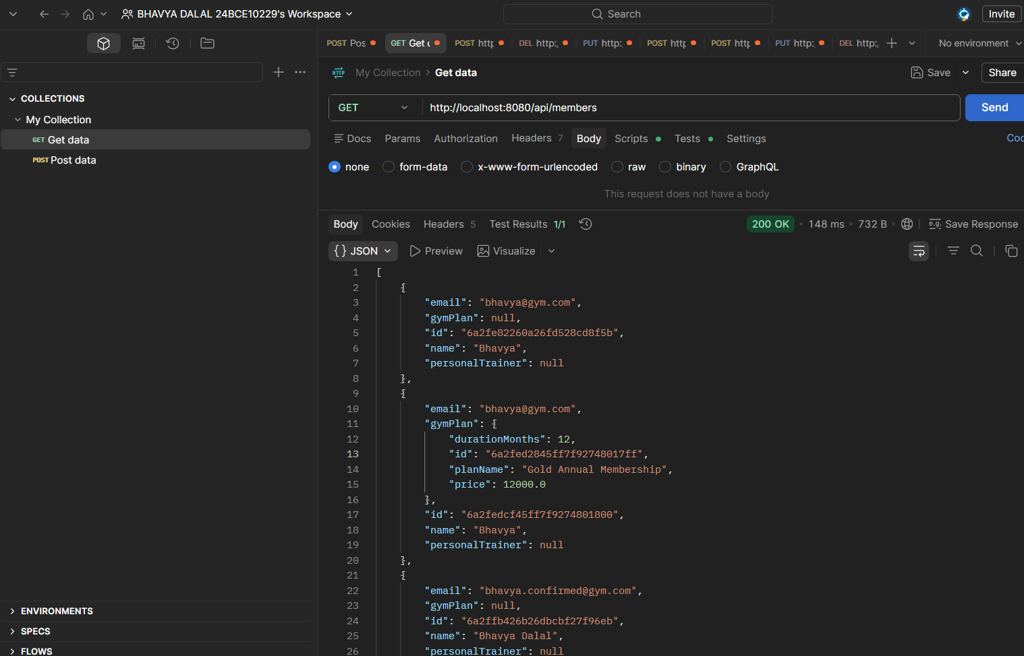

This screenshot demonstrates the retrieval of all member records stored in the database.
The application fetches information from MongoDB and returns a collection of registered gym members. Each member entry includes important details such as name, email address, membership information, and associated identifiers.
The response status code "200 OK" confirms that the request was successfully processed and the data was retrieved correctly.
This operation represents the "Read" functionality of the CRUD implementation and helps administrators view all registered members.

Screenshot: POST_create_plans
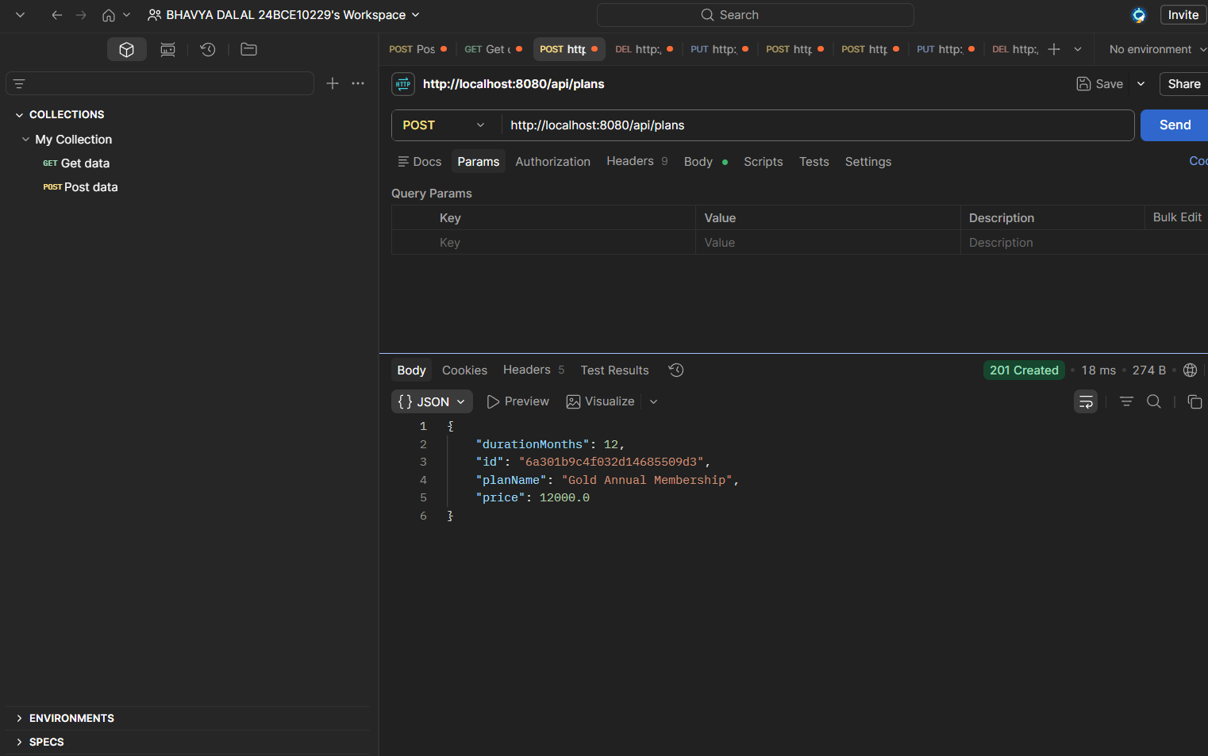
This screenshot shows the successful creation of a membership plan.
The administrator creates a gym plan containing details such as the plan name, duration, and pricing information. Once submitted, the plan is stored in MongoDB and assigned a unique identifier.
The response confirms that the membership plan has been successfully created and saved. The "201 Created" status code indicates successful insertion into the database.
This functionality allows gyms to define multiple membership options for their customers.

Screenshot: PUT_update_members
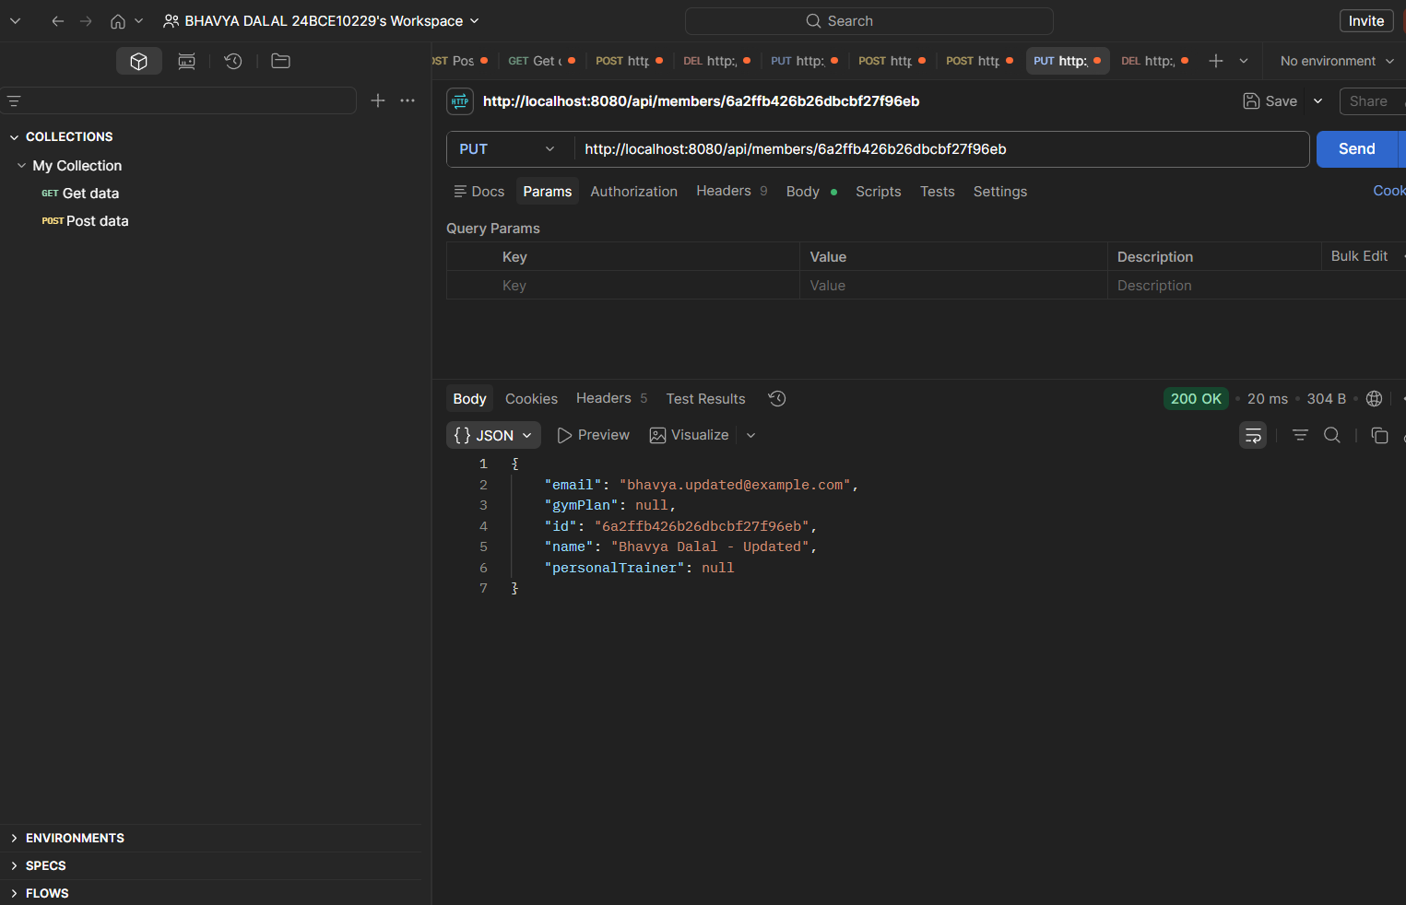
This screenshot demonstrates the updating of an existing member record.
The request modifies previously stored member information such as the member's name and email address. The application locates the corresponding member using the provided identifier and updates the stored information in MongoDB.
The response displays the updated details, confirming that the changes were successfully applied.
The status code "200 OK" indicates that the update operation was completed successfully.
This operation represents the "Update" functionality of CRUD operations.

Screenshot: DEL_delete_member
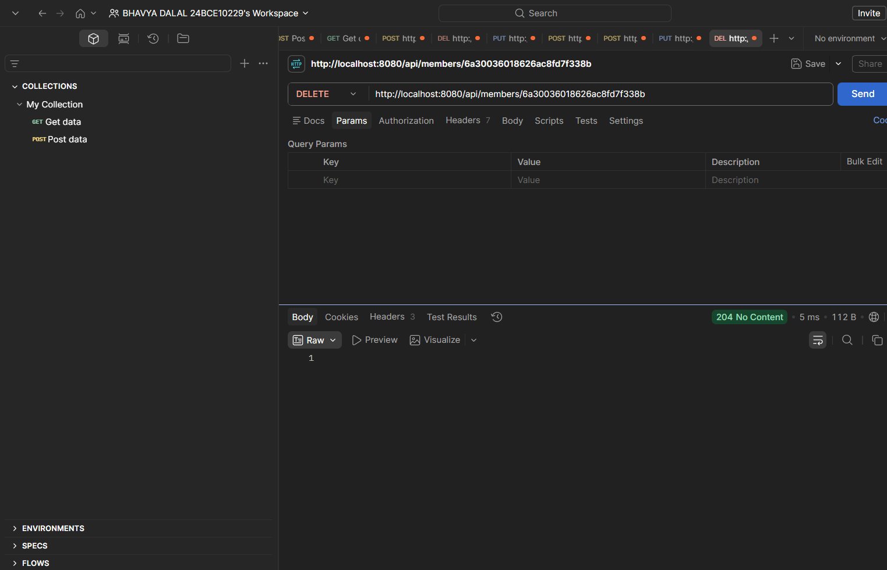
This screenshot demonstrates the deletion of a member record from the system.
The application identifies the member using the specified unique identifier and removes the corresponding record from MongoDB. Since the deletion is successful, no response content is returned.
The status code "204 No Content" confirms that the member was successfully deleted from the database.
This operation represents the "Delete" functionality of CRUD operations and ensures that obsolete or unwanted records can be removed efficiently.

Screenshot: POST_payments_records
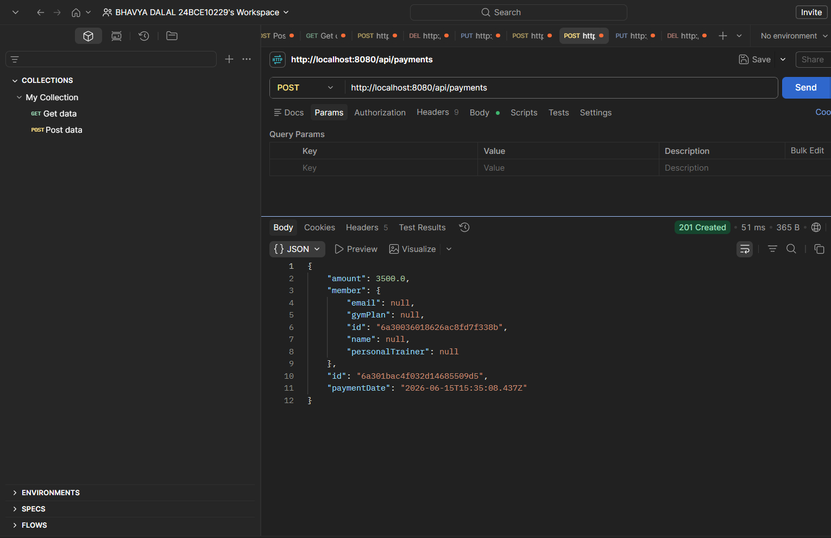
This screenshot demonstrates the recording of a payment transaction made by a gym member.
The payment amount, associated member information, and payment date are stored in MongoDB. The system automatically records the transaction details and generates a unique identifier for the payment entry.
The response confirms successful payment registration and displays the recorded payment information. The "201 Created" status code indicates that the payment record has been successfully inserted into the database.
This functionality enables proper tracking of membership payments and financial records within the gym management system.

5. Conclusion
The Gym Management System successfully demonstrates the implementation of a complete backend application using Spring Boot, MongoDB, REST APIs, Postman, Gradle Wrapper, and Command Prompt. The project provides efficient management of gym members, membership plans, and payment records through well-structured API endpoints.
All CRUD operations were implemented and tested successfully. Membership plans can be created and maintained, while payment records can be tracked effectively. MongoDB ensures reliable data storage, Spring Boot handles application logic, Gradle manages dependencies and builds, and Postman verifies API functionality.
The successful execution of all operations and the corresponding API responses confirm that the system functions as intended and provides a strong foundation for future enhancements such as authentication, frontend integration, reporting, and advanced gym management features.

